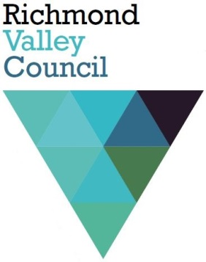
Public Exhibition

Planning Proposal PP2016/0006 – Proposal to Rezone Lot 100, Hills Road, Rileys Hill

Council is in receipt of a Planning Proposal (PP2016/0006) lodged by Ardill Payne and Partners seeking to rezone Lot 100 DP1201719, Hills Road, Rileys Hill to include part of the land within the Rileys Hill village boundary so it can be subdivided to create 35 residential lots.

More specifically, the Planning Proposal seeks to amend the Richmond Valley Local Environmental Plan 2012 (the Planning Scheme for Richmond Valley Council) by:
- rezoning parts of the land from Zone RU1 Primary Production to Zone RU5 Village (about 4.3ha), and Zone E2 Environmental Conservation (about 1.95ha)—with about 2.15ha being retained in Zone RU1 Primary Production;
- to reduce the minimum subdivision lot size (MLS) from 40ha to 800m2 for the area to be zoned RU5 Village and 4ha for the residue area (comprising that part to be Zoned RU1 and E2); and
- to adjust the Dwelling Opportunity Map so the dwelling opportunity is only displayed for that part of the lot that will be Zoned RU1.

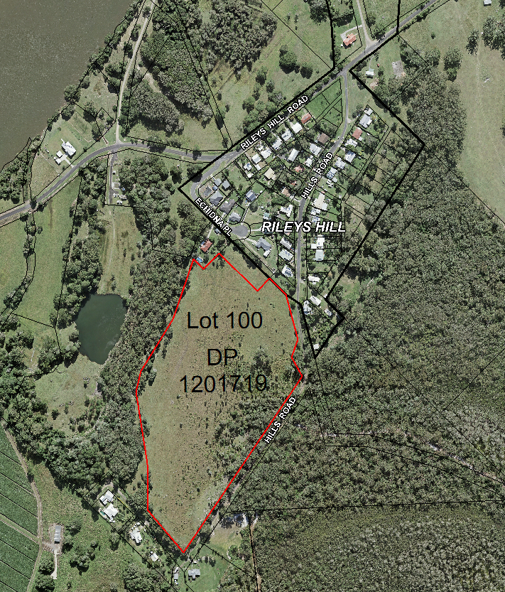
Figure 1 – Location of Lot 100 DP1201719 (with red outline) and its proximity to Rileys Hill
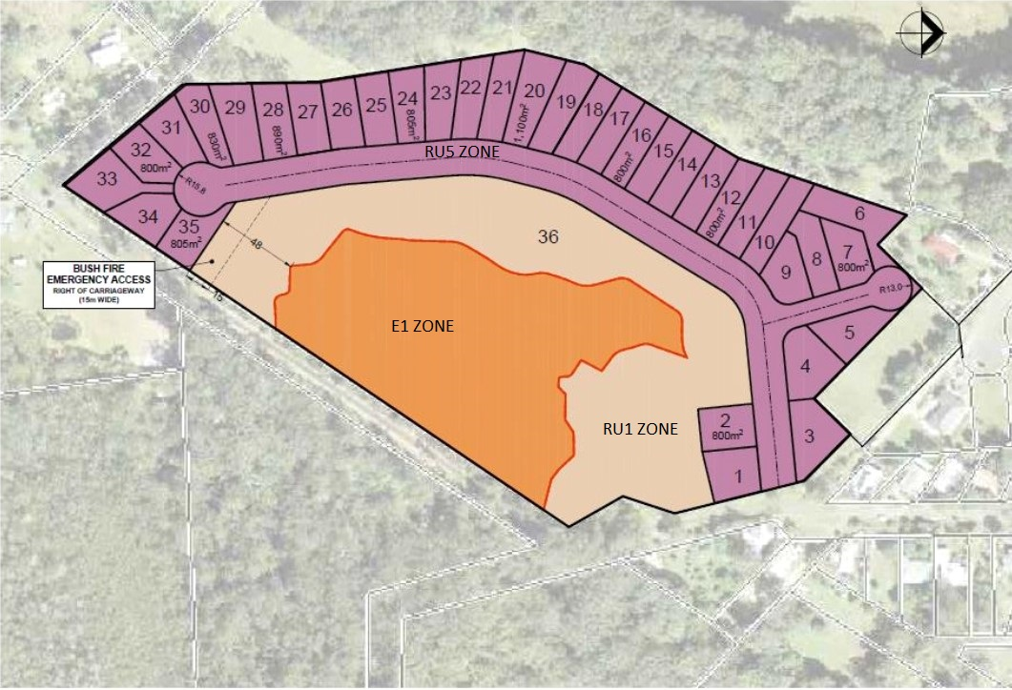
Figure 2: Proposed Subdivision Layout and Zoning

The Planning Proposal and its support documentation will be publicly exhibited from Wednesday, 3 November 2021, with submissions closing on Wednesday, 1 December 2021. All documentation relating to the Planning Proposal may be accessed via the “On Exhibition” page of Council’s Website.
Any person may make written submissions by addressing them to the General Manager:
- Richmond Valley Council, Locked Bag 10, CASINO NSW 2470, or
- by Email to council@richmondvalley.nsw.gov.au , or
- by completing an on-line submission form.
Where a submission is by way of objection the reasons for the objection must be explained.

Notes. All submissions are public documents.
Political Donations must be declared. Further information on declaring Political Donations is available on Council’s website.

Further information on the Planning Proposal is available from Council on (02) 66600300.
-----------------------------------------
For publication:
in the “On Exhibition” page of Council’s website from Wed. 3 Nov to Wed 1 Dec (both dates inclusive); and
as a Social Media post on Council’s Facebook page.

Authorised Tony McAteer, 28 October 2021

